

REGULATIONS MADE IN TERMS OF

Administration of Estates Act 66 of 1965

section 103

General Regulations

RSA Government Notice R.473 of 1972

([RSA GG 3425](http://www.lac.org.na/laws/GGsa/rsagg3425.pdf))

came into force with effect from 1 April 1972 (RSA GN 473/1972)

as amended by

RSA Government Notice R.817 of 1977 ([RSA GG 5542](http://www.lac.org.na/laws/GGsa/rsagg5542.pdf))

**came into force on date of publication: 13 May 1977**

RSA Government Notice R.1209 of 1980 ([RSA GG 7068](http://www.lac.org.na/laws/GGsa/rsagg7068.pdf))

**came into force on date of publication: 13 June 1980**

This amendment is *after the date of transfer*, but it explicitly states that the tariff   
it contains has been determined with the consent of the Administrator-General   
for the Territory of South West Africa and shall also apply in the Territory.

RSA Government Notice R.2532 of 1981 ([RSA GG 7925](http://www.lac.org.na/laws/GGsa/rsagg7925.pdf))

**came into force on date of publication: 20 November 1981**

This amendment is *after the date of transfer*, but it explicitly states that it was   
made with the consent of the Administrator-General for the Territory   
of South West Africa and shall also apply in the Territory.

Government Notice 107 of 1985 ([OG 5128](http://www.lac.org.na/laws/1941/og5148.pdf))

**came into force on date of publication: 15 November 1985**

Government Notice 56 of 1993 ([GG 645](http://www.lac.org.na/laws/1993/645.pdf))

**came into force on date of publication: 1 June 1993**

Government Notice 33 of 1999 ([GG 2051](http://www.lac.org.na/laws/1999/2051.pdf))

**came into force on date of publication: 23 February 1999**

ARRANGEMENT OF REGULATIONS

[The individual regulations have no headings, but are grouped under part headings.]

*Definitions* 1

*Notice of Death* 2

*Inventory* 3

*Affidavit in Terms of Section 25 of the Act* 4

*Liquidation and Distribution Account* 5

*Extension of Period for Lodgment of Account* 6

*Accounts by Tutors and Curators* 7-7A

*Tariff of Remuneration of Executors, Interim Curators, Tutors and Curators* 8

*Tariff of Remuneration and Allowances Payable to Appraisers* 9-12

*Statements of Certain Unclaimed Moneys* 13-15

*Master’s Fees* 16

*Repeal of Regulations* 17

SCHEDULE 1

FORMS

Form A: Death Notice

Form B: Inventory

Form C: Statement of unclaimed moneys

Form D: Statement of unclaimed moneys paid into *guardian’s fund/the South African Bantu Trust Fund

Form E: Affidavit

SCHEDULE 2

TARIFF OF MASTER’S FEES

*Definitions*

**1.** In these regulations, unless the context otherwise indicates -

“Act” means the Administration of Estates Act, 1965 (Act 66 of 1965);

“identity number” means the identity number assigned to a person in terms of section 6 of the Population Registration Act, 1950 (Act 30 of 1950), or section 3 of the Identity Documents in South-West Africa Act, 1970 (Act 37 of 1970); and

[These laws have been repealed. The population register and identity numbers   
are currently governed by the Identification Act 21 of 1996.]

a word or expression to which a meaning has been assigned in the Act bears that meaning.

*Notice of Death*

**2.** The notice of death referred to in section 7 of the Act shall be substantially in the form set out in Form A in Schedule 1.

*Inventory*

**3.** Form B in Schedule 1 shall, by deleting therefrom matter which is not applicable in the relevant circumstances, be applied to make an inventory in pursuance of sections 9, 27 or 78 of the Act.

*Affidavit in Terms of Section 25 of the Act*

**4.** The affidavit required by section 25 of the Act shall be made by the person referred to in section 21 of the Act in whose favour letters of executorship have been granted and shall specify -

(a) that it is an affidavit in terms of section 25 of the Act;

(b) the full name of the deceased;

(c) the full name and address of the deponent;

(d) the place and country or territory wherein the the deceased was ordinarily resident at the time of his death;

[The word “the” is repeated in the *Government Gazette*, as reproduced above.]

(e) the place, country or territory and date of death of the deceased, and whether the death has been registered by the authorities of the country or territory concerned;

(f) whether letters of executorship have been granted and, if so, in whose favour and where such letters have been granted;

(g) whether the deceased died intestate or left a will and, in the latter event, whether such will has been accepted as a valid will;

(h) that the deceased was not the owner of any property in the Republic of Namibia other than moveable property;

[paragraph (h) substituted by GN 33/1999]

(i) particulars of such movable property;

[paragraph (i) substituted by GN 33/1999]

(j) whether any usufructuary, fiduciary or fideicommissary or other like interest in property within the Republic in favour of the deceased has ceased upon his death and, if that be the case, particulars thereof;

(k) the full name and address of any beneficiary in the estate of the deceased, resident in the Republic;

(l) the full name and address of any person in the Republic having any claim against the estate of the deceased and details of such claim, or that, to the knowledge of the deponent, no person in the Republic has any claim against the estate of the deceased;

(m) that to the knowledge of the deponent no person in the Republic can be prejudiced by the transmission of property in the estate of the deceased to the person in whose favour letters of executorship have been granted or to his duly authorised agent; and

(n) the full name and address of any duly authorised agent in the Republic acting on behalf of the person in whose favour letters of executorship have been granted.

*Liquidation and Distribution Account*

**5.** (1) The account referred to in section 35(1) of the Act shall -

(a) contain a heading which shall -

(i) describe it as a liquidation and distribution account;

(ii) reflect the ordinal number of such account;

(iii) specify whether it is a final or supplementary or an amended final or supplementary liquidation and distribution account, as the case may be;

(iv) state the full name and surname and date of death of the deceased, and, if an identity number was assigned to the deceased, such identity number also;

(v) state the marital status of the deceased at the date of his death;

(vi) if the deceased was a married person at the date of his death, state whether the marriage was in or out of community of property and, if the marriage was in community of property, the full name (including a maiden name, if applicable) of the person to whom he was so married, and, if an identity number has been assigned to that person, state such identity number also;

(vii) specify, if adiation has taken place, that it is the massed estate of the deceased and the person who has so adiated; and

(viii) state the Master’s reference number;

(b) contain a money column;

(c) specify under a subheading “Liquidation Account” -

(i) the immovable property (other than property subject to a fideicommissum) forming part of the estate as described in the title deed thereof and reflect the number and date of the title deed and, in the case of an amended description of such property, also specify such amended description;

(ii) an accurate and concise description of the movable property (not subject to a fideicommissum) forming part of the estate;

(iii) in parentheses next to the money column of the account a consecutive number in respect of each item under this subheading, such number to correspond, where applicable, to the serial number of the voucher, receipt or acquittance referred to in subregulation (3), relating to such item;

(iv) in the money column of the account, the value of each asset or a number of assets grouped together or the gross proceeds of each asset or a number of assets grouped together and sold by the executor;

(v) the manner in which the executor intends dealing with or divesting the estate of any asset or group of assets, other than cash found in the estate or cash proceeds from assets realised,

and then the money column shall be totalled and thereafter the account shall, under this subheading, further specify -

(vi) in the money column, the administration charges incurred in connection with the liquidation and distribution of the estate;

(vii) the name of each creditor, together with the amount of his claim which shall be reflected in the money column of the account;

(viii) in the money column, any estate duty payable by the estate,

and the amounts reflected in the money column in respect of subparagraphs (vi) to (viii), inclusive, shall be totalled and any balance for distribution to be carried forward to the distribution account shall be reflected in such column;

(d) specify under a subheading “Recapitulation Statement” a cash statement reflecting -

(i) the total of the items comprising cash or property reduced to cash;

(ii) the total debts and charges appearing under the subheading “Liquidation Account” and any legacy payable in cash; and

(iii) the cash deficiency, if any, and how such deficiency will be settled;

(e) specify under a subheading “Distribution Account” -

(i) the balance for distribution and particulars of any rights conferred under the provisions of section 37 of the Act;

(ii) the full names of the heirs and whether an heir is a major or a minor and married or unmarried, and in the case of -

(aa) a minor, also the date of birth, and if an identity number has been assigned to such minor, also such identity number;

(bb) a woman, also her marital status and, if married in community of property, the full name of her husband;

[subparagraph (ii) substituted by GN 33/1999]

(iii) briefly details of the property included in every award and the reason for every award and if the award to any beneficiary or administrator is subject to any condition in the will, stating that it is made subject to and in terms of such condition without specifying or summarising the terms of the condition,

and where any redistribution agreement was entered into by the heirs and distribution has to be made by the executor pursuant to such agreement, the redistribution agreement shall accompany the account;

(f) specify under a subheading “Income and Expenditure Account” -

(i) any income collected which has accrued subsequent to the death of the deceased to the date of the account;

(ii) any expenses paid from such income;

(iii) in parenthesis next to the money column of the account, a consecutive number in respect of each entry;

(iv) the balance available for distribution and to whom it was awarded;

and if no income was collected, that fact shall be stated;

(g) specify under a subheading “Fiduciary Assets Accounts” -

(i) *mutatis mutandis* in the manner set out in subparagraph (c) of this regulation, the fiduciary assets held by the deceased as a fiduciary pursuant to any will or other instrument;

(ii) the origin of the fiduciary interest in such assets, including the Master’s reference number of the estate, will or instrument in terms of which such interest was created;

(iii) any debts, charges and administration expenses which are chargeable against such fiduciary assets;

(iv) in so far as the provisions of subparagraphs (e) and (f) of this regulation may be applied to the fiduciary assets account, the information required by those provisions;

(h)

[paragraph (h) deleted by GN 33/1999]

(i) conclude with a certificate signed and dated by the executor in which he -

(i) declares that the account is to the best of his knowledge and belief a true and proper account of the liquidation and distribution of the estate;

(ii) declares, if it is a final account, that to the best of his knowledge and belief all the assets and income collected subsequent to the death of the deceased to the date of the account have been disclosed therein; and

(iii) sets forth, if the account is not a final account, full particulars of all the debts due to the estate and still outstanding and all assets, stating the approximate value of each asset, still unrealised with an explanation why such debts and assets have not been collected or realised.

(2) Where the estate has been liquidated and distributed or the assets in the estate have been realised and the proceeds distributed under the provisions of section 34 of the Act, the account shall, subject to the provisions of section 34(5)(b) of the Act, consist of -

(i) a liquidation account framed in accordance with the provisions of section 92 of the Insolvency Act, 1936 (Act 24 of 1936);

(ii) a trading account containing the particulars referred to in section 93 of the Insolvency Act, 1936, if any business is carried on on behalf of the estate;

(iii) a distribution account in the form referred to in section 94 of the Insolvency Act, 1936;

(iv) a certificate by the executor that the requisite majority in number and value of the creditors did not instruct him to surrender the estate under the Insolvency Act, 1936;

(v) a liquidation and distribution account in respect of protected assets which are not subject to the rights of creditors *mutatis mutandis* in the form prescribed by subregulation (1)(c), (e), (f) and (g) in so far as the said subregulation can be applied;

(vi) a certificate containing the particulars referred to in subregulation (1)(i).

(3) Every voucher, receipt or acquittance in support of any asset or number of assets grouped together or of each claim or charge against the estate shall be numbered with a number corresponding to the number of the item to which it relates.

(4) The account referred to in section 35(2) of the Act shall, in so far as it is appropriate, contain the particulars referred to in subregulation (1) and (2).

(5) If the Master is satisfied that non-compliance with any of the requirements mentioned in subregulation (1) is not material, he or she can waive compliance therewith.

[subregulation (5) inserted by GN 33/1999]

*Extension of Period for Lodgment of Account*

**6.** Any executor who for good reason is unable to lodge the account referred to in section 35(1) of the Act within the period referred to in that section shall make application, in writing, to the Master for a further period within which to lodge such account and shall specify in such application -

(a) why the account cannot be rendered within the period mentioned in that section;

(b) the steps taken by him or her to expedite the submission of the account and what progress has been made;

(c) what progress has been made in the liquidation or realisation of the estate;

(d) what moneys he or she has in hand or have been deposited in an account or savings account opened in the name of the estate and why an interim account referred to in section 35(2) of the Act should not be submitted to the Master;

(e) if a written report has not been made to the Master in terms of section 34(1) of the Act, whether the estate is solvent.

[regulation 6 substituted by GN 33/1999]

*Accounts by Tutors and Curators*

**7.** The account referred to in section 83(1) and (2) of the Act shall -

(1) contain a heading which shall -

(a) describe it as a tutor’s or curator’s account, as the case may be;

(b) reflect the ordinal number of such account and, when it is a final account, state such fact;

(c) specify the full name of the minor or other person concerned and, in the case of a minor, also the date of birth;

(d) specify the period in respect of which the account is rendered and state whether it is an account in terms of section 83(1) or (2) of the Act; and

(e) reflect the Master’s reference number;

(2) contain a money column;

(3) specify under a subheading “Income and Expenditure Account” -

(a) any credit balance of income or a deficiency brought forward from a previous account lodged with the Master in respect of the administration of the property concerned;

(b) all income actually collected reflecting the source from which it is derived;

(c) any money transferred from the “Capital Account” referred to in subregulation (4) to meet debts and charges;

(d) all debts and maintenance charges paid by the tutor or curator during the period in respect of which the account is rendered, specifying the nature thereof and the name of the payee;

(e) all administration expenses, separately reflected, the name of the payee and the nature of the charge;

(f) the debit or credit balance, as the case may be, which shall, in the case of a debit balance, contain a statement whether this has been paid out of the “Capital Account” referred to in subregulation (4) or is being carried forward to the next account;

(g) whether any credit balance has to be carried forward to the “Capital Account”, so referred to, or will be required for immediate use; and

(h) in parentheses next to each item a consecutive number;

(4) specify under a subheading “Capital Account” -

(a) an accurate description of all property under the control of the tutor or curator at the end of the period in respect of which the account is rendered;

(b) the rate of interest on all investments bearing a predetermined rate of interest;

(c) any credit balance shown under the subheading “Income and Expenditure Account” and brought forward as provided in subregulation (3)(g);

(d) a description of any property leased, with a reference to the lease, the full name of the lessee, the period of the lease and the annual rental thereof;

(e) the amount of any capital asset or part thereof realised, with a description of such asset, and the amount of any money transferred to the “Income and Expenditure Account” as provided in subregulation (3)(c), with reasons for such transfer;

(f) all capital debts owing by the person for the administration of whose property the tutor or curator has been appointed; and

(g) in a footnote under this subheading any income due but not collected, the reason why such income has not been collected and the steps taken by the tutor or curator to collect such income;

(5) under a subheading “Cash Reconciliation Statement” reconcile the cash reflected under the subheadings “Income and Expenditure Account” and “Capital Account” with the banking account as at the end of the period in respect of which the account is rendered, and every voucher, receipt or acquittance supporting such account shall bear a number corresponding to the number of the item in the account in support of which it is lodged;

(6) conclude with a certificate by the tutor or curator in which he declares that -

(a) the account is to the best of his knowledge and belief a true and proper account of his administration of the relative property of the minor or other person during the specified period in respect of which the account is rendered; and

(b) to the best of his knowledge and belief the account reflects all property of and all debts owing by the person for the administration of whose property he has been appointed and all income collected and debts, expenses and charges paid by him during the period covered by the account and that he is not aware of any disputed right to assets or liabilities.

**7A.** If the Master is satisfied that the non-compliance with any of the requirements mentioned in regulation 7 is not material, he or she can waive compliance therewith.

[regulation 7A inserted by GN 33/1999]

*Tariff of Remuneration of Executors, Interim Curators, Tutors and Curators*

**8.** (1) The executor’s remuneration referred to in section 51(1)(b) of the Act shall be assessed according to the following tariff:

(a) On the gross value of assets in an estate: 3,5 per cent;

(b) on income accrued and collected after the death of the deceased: 6 per cent:

Provided that the remuneration in respect of any deceased estate shall not be less than N$350,00.

[subregulation (1) substituted by RSA GN R.2542/1981 and by GN 33/1999, which provides that the substituted provision applies only in relation to estates of persons who died on or after the date of promulgation of the amendment: 23 February 1999 (see 6(2) of GN 33/1999).]

(2) An interim curator appointed under section 12 of the Act shall be entitled to a remuneration of one-eighth per cent on the gross value of the estate under his custody on the date upon which letters of executorship are granted or signed and sealed or upon which any person is directed to liquidate and distribute the estate.

(3) The remuneration of tutors and curators referred to in section 84(1)(b) of the Act shall be assessed according to the following tariff:

(a) On income collected or accrued during the existence of the tutorship or curatorship: 6 per cent;

(b) on the value of capital assets on distribution, delivery or payment thereof on termination of the tutorship or curatorship: 2 per cent.

[subregulation (3) substituted by GN 33/1999]

*Tariff of Remuneration and Allowances Payable to Appraisers*

**9.** (1) Every appraiser is entitled to receive remuneration according to the following tariff in respect of every separate or continuous appraisement made for the purposes of the Act:

|  |  |
| --- | --- |
|  | N$ |
| (a) Valuations of N$5 000 or less | N$100 |
| (b) Valuations exceeding N$5 000 up to and including N$10 000 | N$120 |
| (c) Valuations exceeding N$10 000 up to and including N$20 000 | N$140 |
| (d) Valuations exceeding N$20 000 up to and including N$300 000 | N$10 for the first N$20 000 and N$2,00 per N$1 000 or part thereof thereafter |
| (e) Valuations exceeding N$300 000 up to and including N$800 000 | N$700 for the first N$300 000 and N$1,50 per N$1 000 or part thereof thereafter |
| (f) Valuations exceeding N$800 000 | N$1 450 for the first N$800 000 and N$ 1,00 per N$1 000 or part thereof thereafter |

(2) In subregulation (1), “continuous appraisement” means an appraisement of two or more properties situated in the same locality or region where the facts and features considered in valuing one of them are of substantial assistance in valuing the other or others.

[regulation 9 substituted by GN 107/1985 and by GN 33/1999]

**10.** (1) In addition to the remuneration set out in regulation 9 the following transport allowance may be claimed in all cases in which the appraisement is made at a place more than two kilometres from the place of business of the appraiser:

(a) When own conveyance is used, N$3,00 per kilometre;

(b) When public transport is used, the actual cost;

(c) When conveyance is hired, the actual cost.

(2) Where, in the course of one journey, appraisements are made on the instructions of two or more persons, the transport allowance claimed in respect of that journey shall be recovered pro rata from the persons concerned.

(3) No transport allowance shall be claimed when the person desiring the appraisement provides suitable and safe transport: Provided that, where transport which is uninsured in respect of third party risk, other than compulsory third party risk, is offered, the appraiser need not accept such conveyance but shall be free to proceed as if no transport facilities have been offered.

[regulation 10 amended by RSA GN R.817/1977, RSA GN R.1209/1980,   
GN 107/1985 and GN 56/1993, and substituted by GN 33/1999]

**11.** In addition to the remuneration and transport allowances set out in regulations 9 and 10, the following allowances may be claimed -

(a) for the time spent in travelling to and from the places of appraisement: N$30 per completed half-hour, but not exceeding N$300 per day;

1. for any necessary delay while the appraiser is not engaged in the appraisement: N$30 per completed half-hour, but not exceeding N$300 per day.

[regulation 11 substituted by RSA GN R.817/1977, RSA GN R.1209/1980,   
GN 107/1985, GN 56/1993 and GN 33/1999]

**12.** An account in respect of an appraisement submitted by an appraiser to the Master for taxation shall be accompanied by a copy of the appraisement concerned and shall -

(a) if a transport allowance is claimed -

(i) give full particulars of the distance actually and necessarily travelled; and

(ii) contain a statement that the journey was undertaken for the purpose of the appraisement;

1. if a subsistence allowance is claimed, give particulars of the time occupied in travelling and the time of any necessary delay.

[regulation 12 substituted by GN 33/1999]

*Statements of Certain Unclaimed Moneys*

**13.** The statements referred to in section 93 (1) of the Act shall be prepared in the form set out in Form C in Schedule 1.

**14.** The statement and affidavit referred to in section 93 (3) of the Act shall be prepared in the form set out in Forms D and E, respectively, in Schedule 1.

**15.** The surnames and first names of the rightful owners, in that order, alphabetically arranged, and their last known addresses shall, as far as practicable, be furnished in the statements referred to in regulations 13 and 14.

*Master’s Fees*

**16.** The matters in respect of which Master’s fees shall be payable, the tariff of such fees and the manner in which such fees shall be payable shall be as specified in Schedule 2 to these regulations.

*Repeal of Regulations*

**17.** (1) Subject to the provisions of subregulation (2), the regulations published under Government Notice R. 1534, dated 29 September 1967, are hereby repealed.

(2) The estate of any person who died before the commencement of these regulations shall be liquidated and distributed and any matter relating to the liquidation and distribution of such estate shall be dealt with as if these regulations had not been made.

SCHEDULE 1

To view content without printing, scroll down.

To print at full scale (A4), double-click the icon below.

 

[Form A substituted by GN 33/1999]

**[Form A substituted by GN 33/1999]**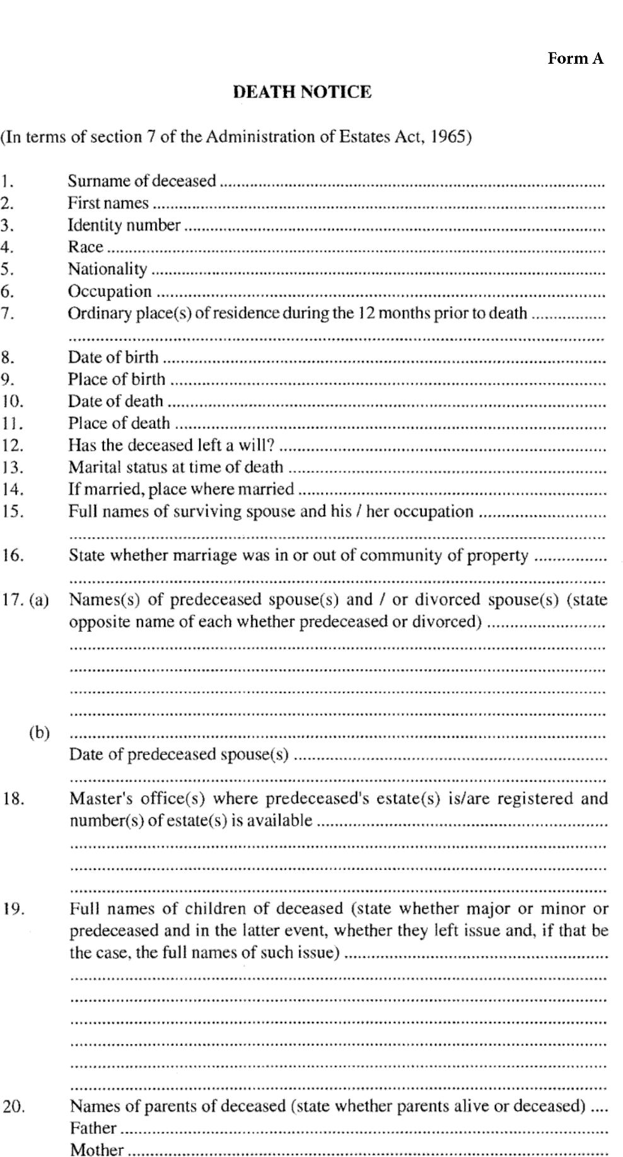 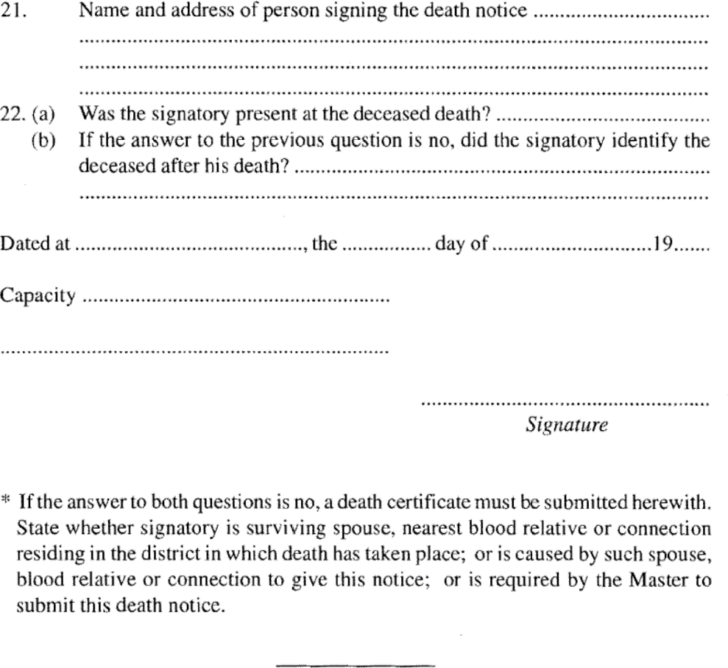

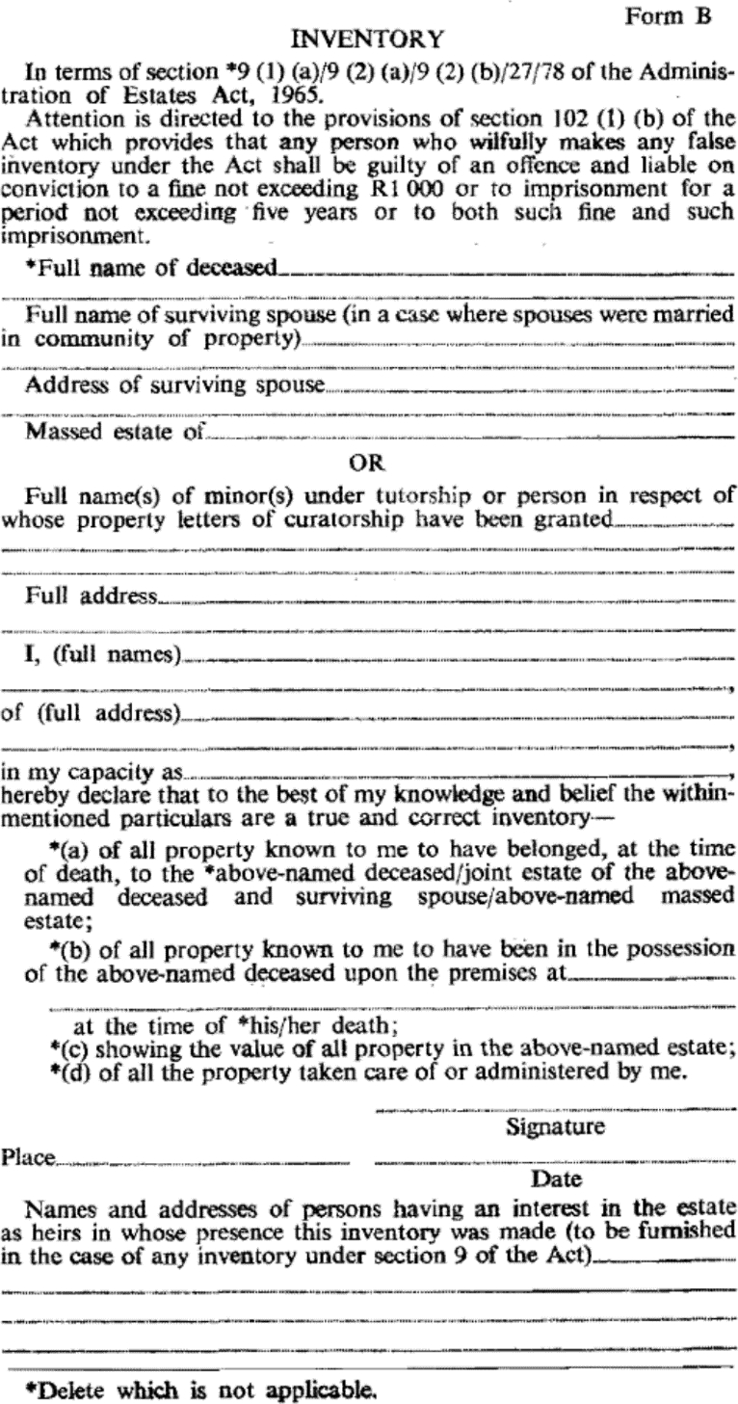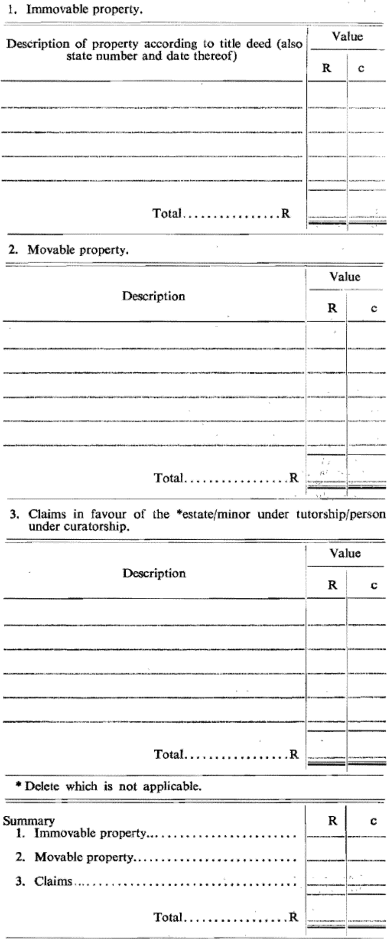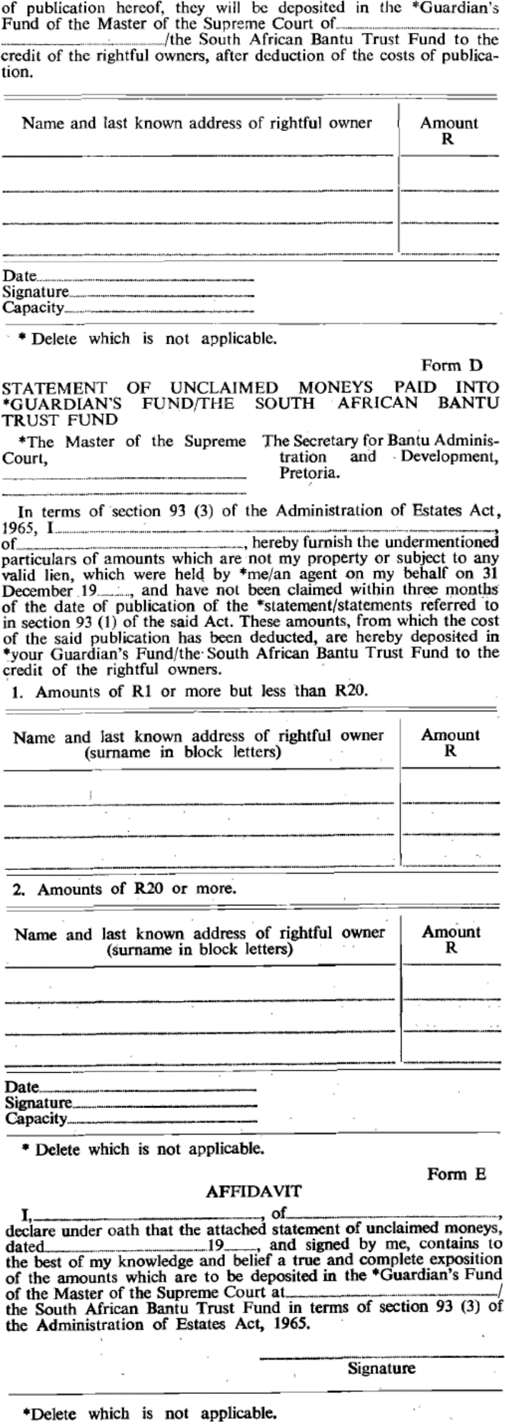

SCHEDULE 2

TARIFF OF MASTER’S FEES

**1.** (1) On all estates, including all fiduciary assets, of deceased persons or estates under curatorship, except estates under the custody of an interim curator pending the appointment of an executor, the gross value of which according to the executor’s or curator’s account -

1. is equal to or less than the amount referred to in section 18(3) of the Act, N$0,00;

(b) is more than the amount referred to in section 18(3) of the Act, N$3,00 for every completed N$1 000, but subject to a maximum fee of N$3 000,00.

Where the deceased was one of two spouses married in community of property the said fees shall be assessed on the gross assets of the estate.

[subitem (1) substituted by GN 33/1999, which provides that the substitution applies only   
in relation to estates of persons who died on or after the date of promulgation   
of the substitution: 23 February 1999 (see 12(2) of GN 33/1999)]

(2) The fees referred to in subparagraph (1) shall be assessed by the Master and shall be payable to any receiver of revenue. Proof of such payment shall be submitted by the executor or curator to the Master.

**2.** (1) (a) For a copy of or an extract from any document preserved of record in the office of a Master when made in such office (including certification of such copy or extract): N$5,00.

[paragraph (a) amended by GN 33/1999]

(b) For certifying such copy or extract when not made in such office: N$10,00.

[paragraph (b) amended by GN 33/1999]

(2) The fees referred to in subparagraph (1) shall be payable by means of revenue stamps affixed to an application made to the Master, in writing, for the required service.

**3.** Upon all unclaimed moneys being paid into the hands of a Master in pursuance of section 93 of the Act or for account of absent or unknown creditors of any estate or for account of absent or unknown creditors or contributories of any company a commission upon the amount paid in of five per cent shall be payable in cash and be deducted from the unclaimed moneys so paid into the hands of the Master.